Account Creation

From the user stories that we devised, it became clear that we would need two types of account; seller accounts and customer accounts. This led to some issues arising regarding the page in which users would create their account.

The initial plan was to have two radio buttons in the form that the user would need to fill out to create an account, so that the user can simply select the type of account that they wanted. However, upon creation of the database we discovered that this could not be the case as each account requires different details.

Before integration of Oracle, we used a temporary phpMyAdmin database.

This is the temporary database for the customer accounts:

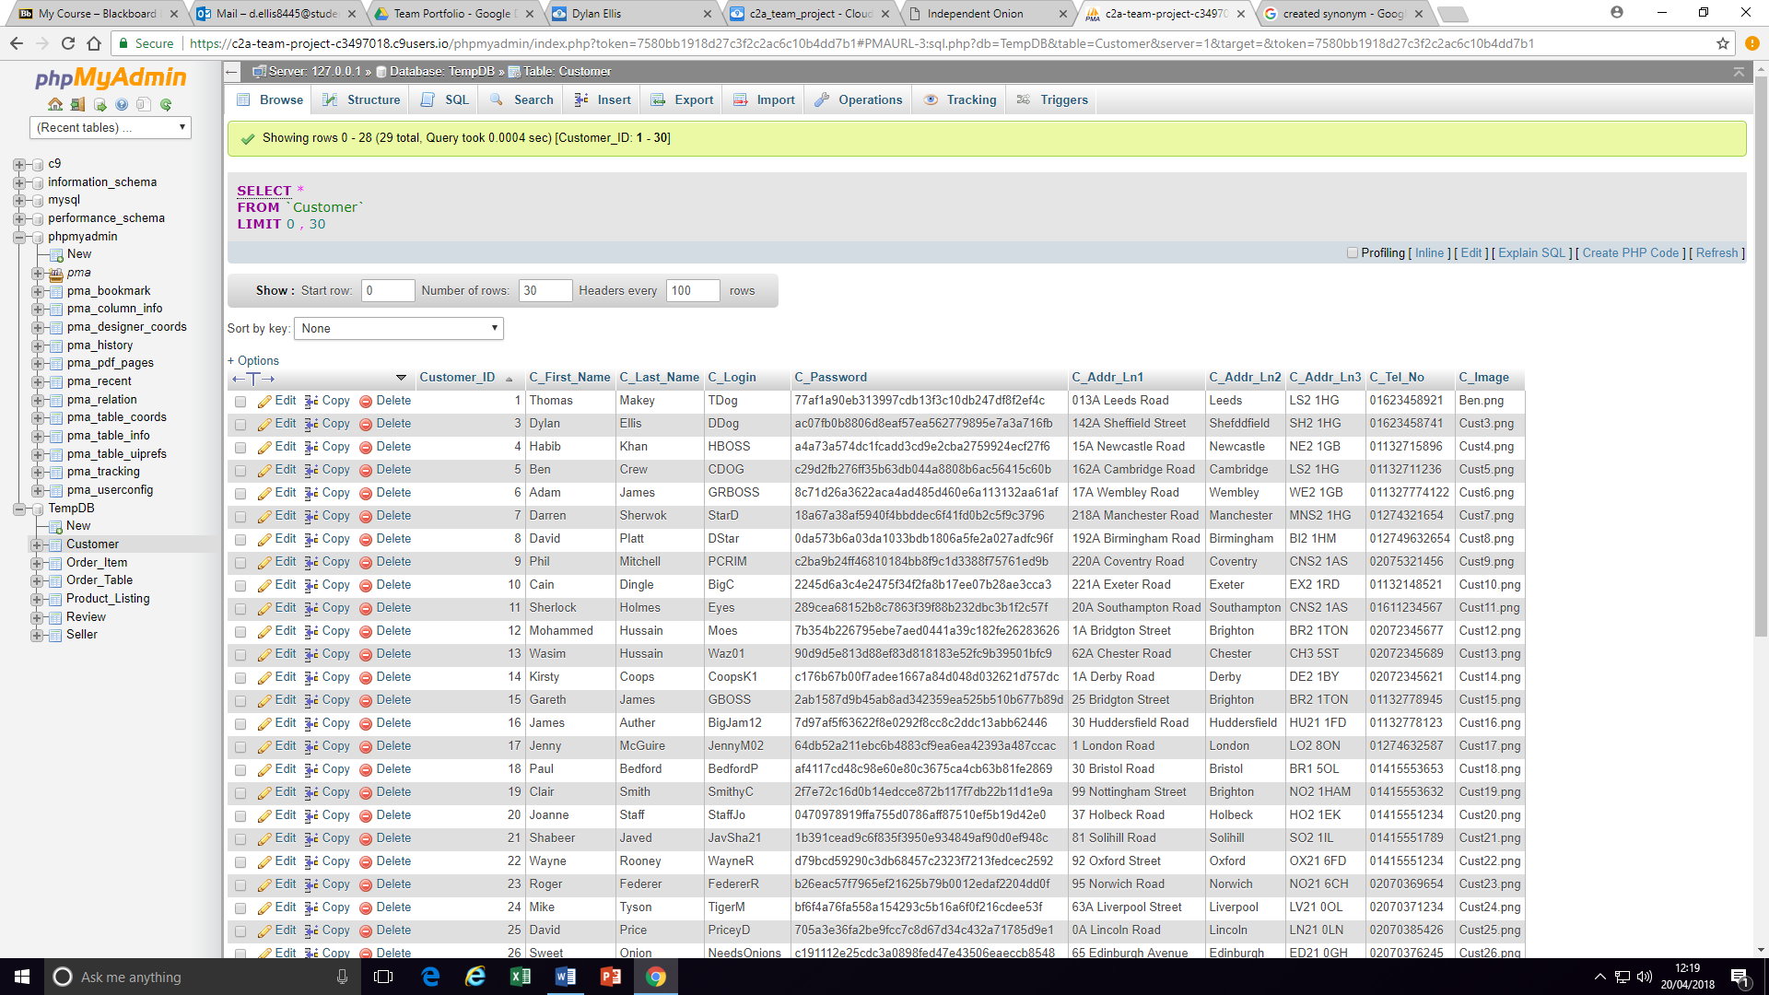

This is the temporary database for the seller accounts:

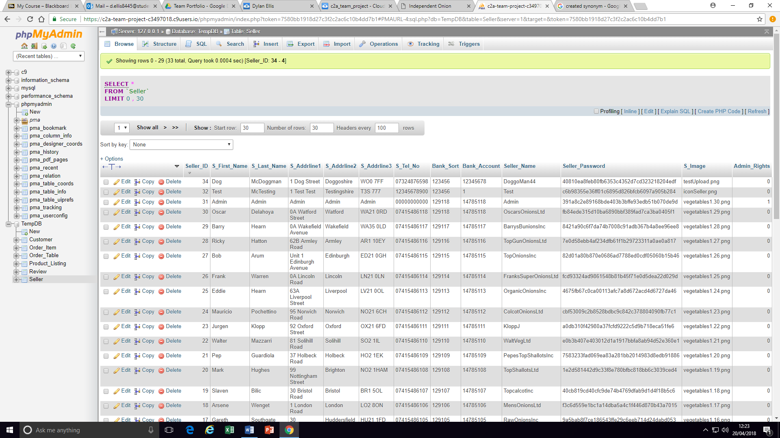

The point of these screenshots is to demonstrate why one account creation form would not suffice. The fields that need to be filled differ too much. To do this correctly, two separate account creation forms would be required, one for each type of account.

This begged the question ‘how do we accomplish this while still presenting a user friendly interface?’

Firstly, we tried having two separate registration links in the navigation bar.



We didn’t like the aesthetic of this; a single ‘register’ link would be ideal.

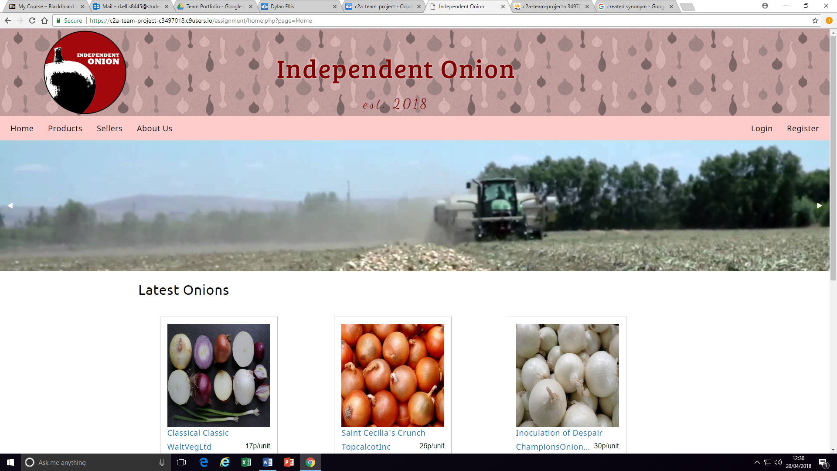

Given that we were now working with a single link, we thought that the most user intuitive way we could offer two forms would be for the ‘Register’ link to lead to the choice of accounts. This led to the formation of this screen:

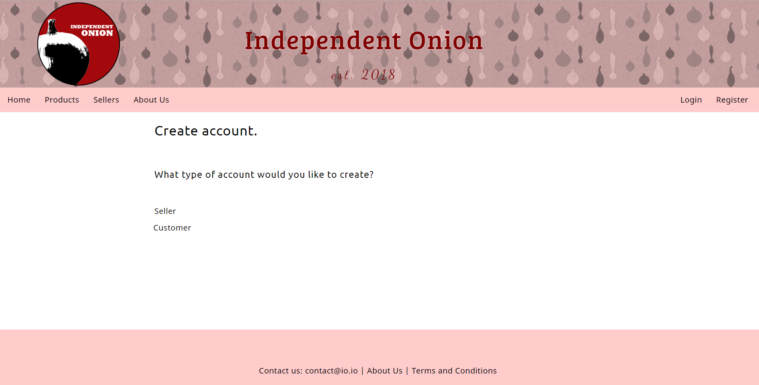

Functionally this was perfect, but the page itself looked too empty. A workaround would be to make it more visual, which led to the page becoming this:

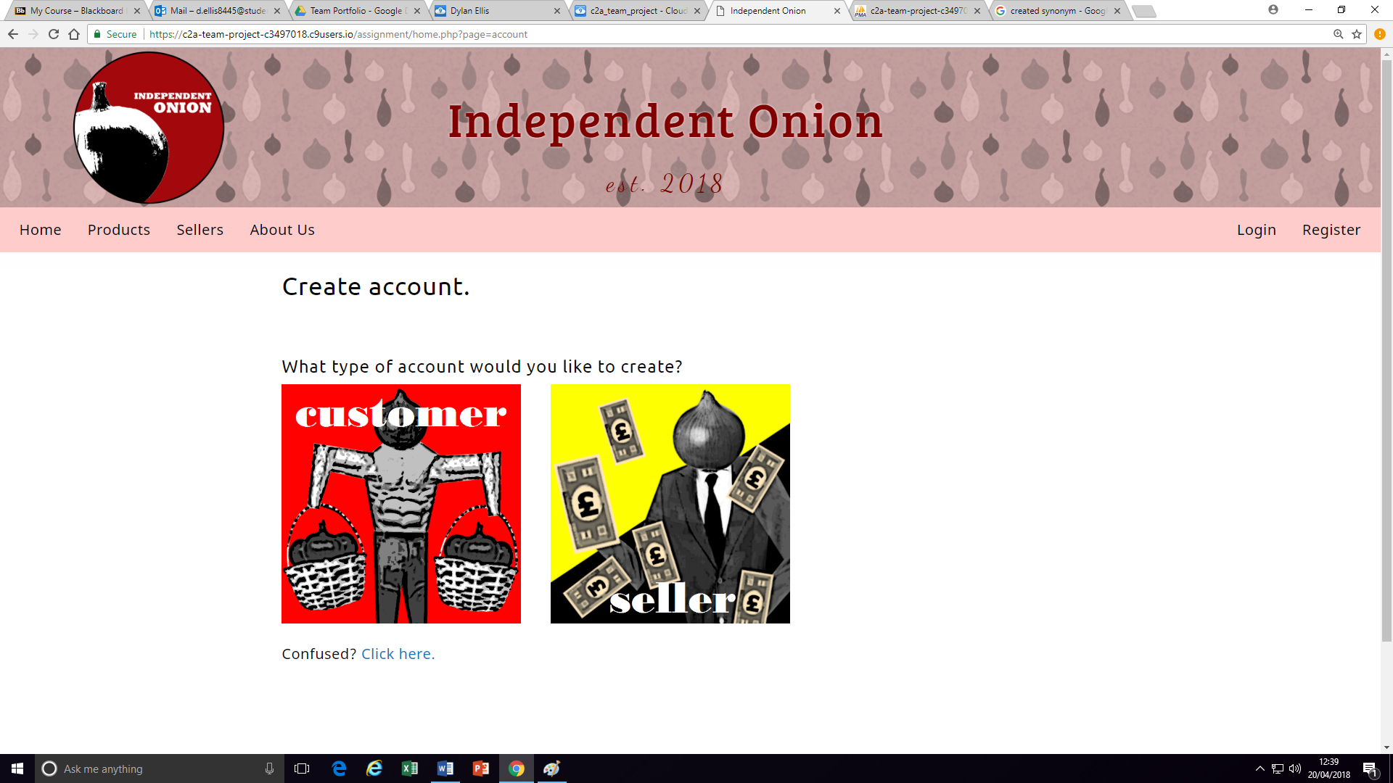

To offer users assistance, should they require it, the ‘click here’ link offers a description of each account type in the form of a pop up window; we figured that this would be the least disruptive way to do this.

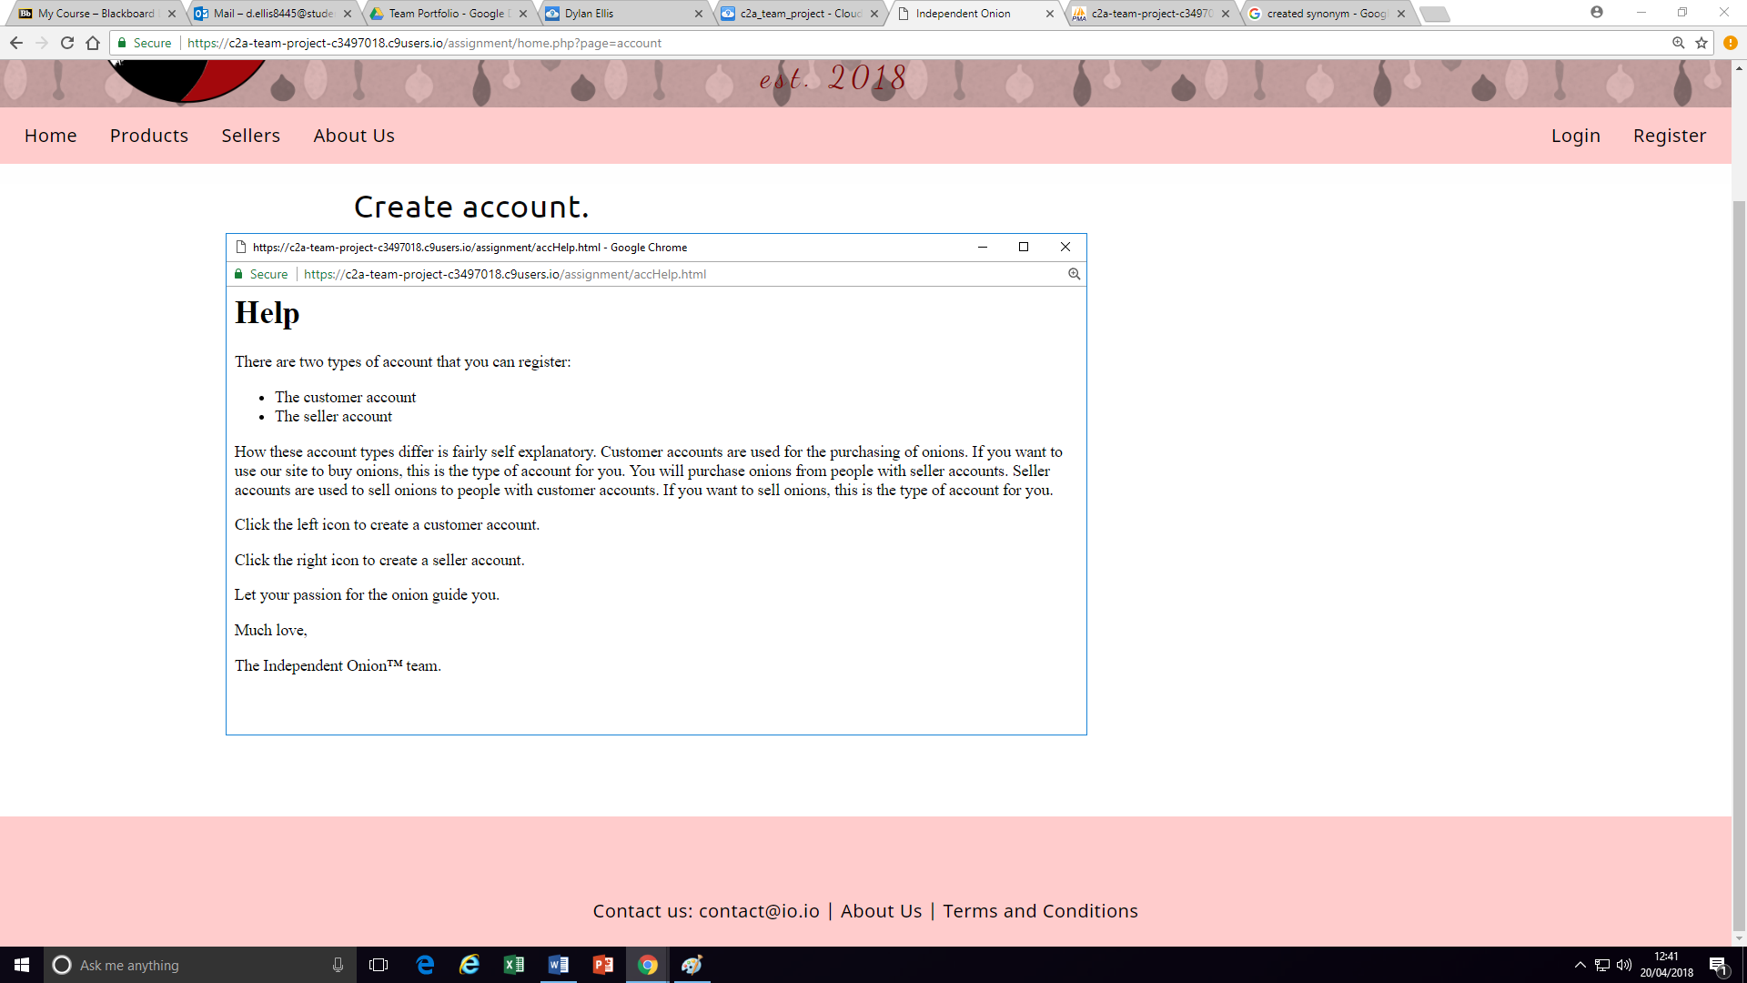

Then came the process of creating the forms.

The customer registration form:

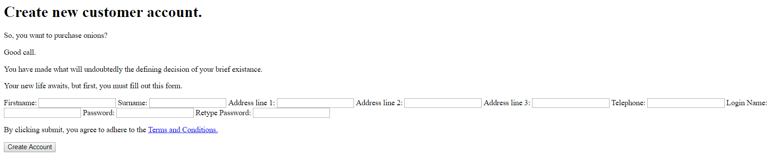

The seller registration form:

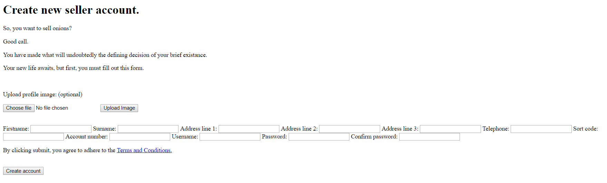

These forms retrieve data from the user then store the data as variables. Validation in then performed, and if the data is found to be valid an SQL INSERT query is used to populate the user’s data into the database.

The last thing to do was to write CSS for the forms. The same CSS applies to both forms, and so one screenshot will suffice to demonstrate this.

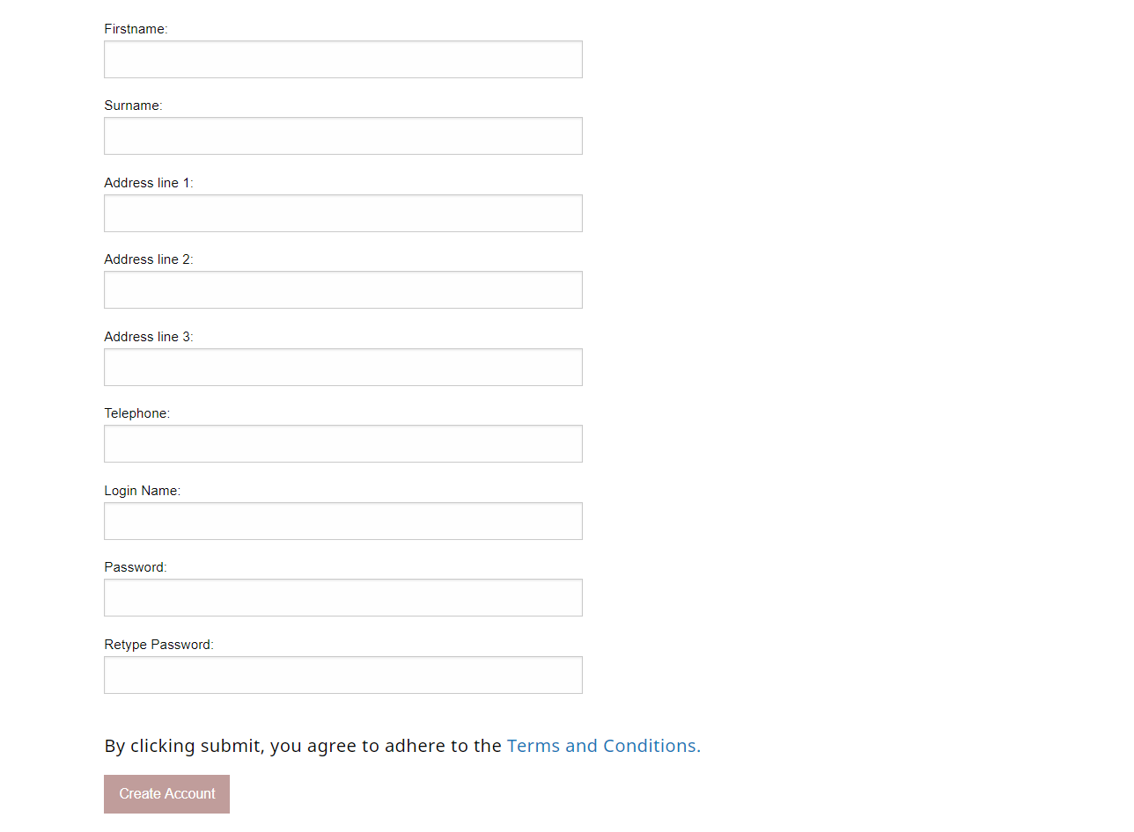

Verticality was added as we thought this would be the most user friendly way of displaying the form. Most websites display registration forms in a similar fashion, so opted to use the universal standard.